**Enrolment No.:** 92100588045 **Name**: Rohit Luni

**Practical Exam**

**Descriptions:**

Automatic Irrigation system using Soil moisture sensor and motor.

If the soil is dry then motor is start otherwise it will be off

Soil Moisture: Soil Moisture is sensor to sense the moisture of the soil and give me value of the moisture to

The with this moisture we can use it to check whether the soil is dry or not

Moter: Here the motor is used to start the irrigation or you can used instead of motor you can used the pump.

LED: Here the LED is for the indicating to the motor is on of off

**Circuit Diagram:** (Download from tinkercad.com)

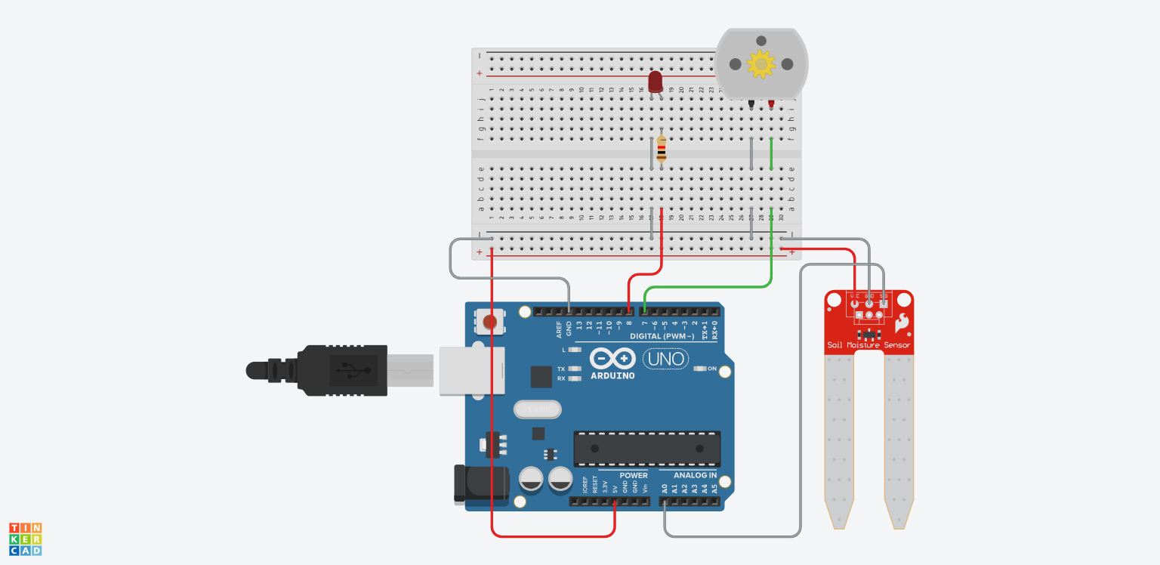

**Schematic View:** (Download from tinkercad.com)

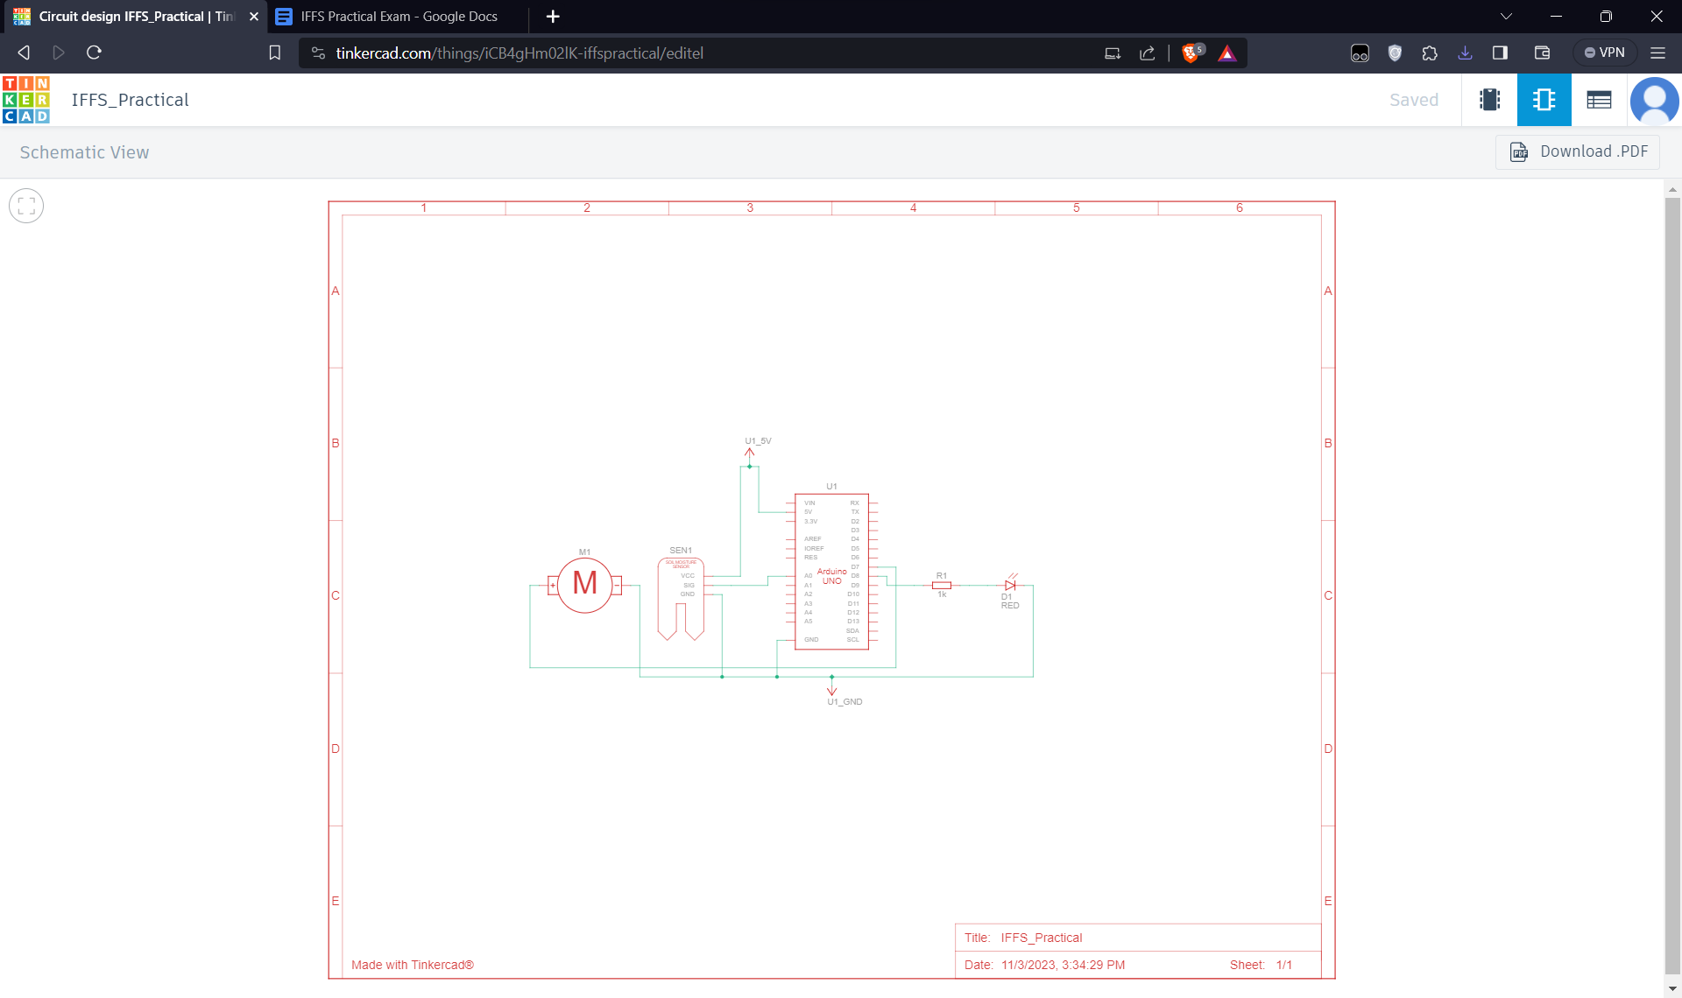

**Component List:** (Download from tinkercad.com)

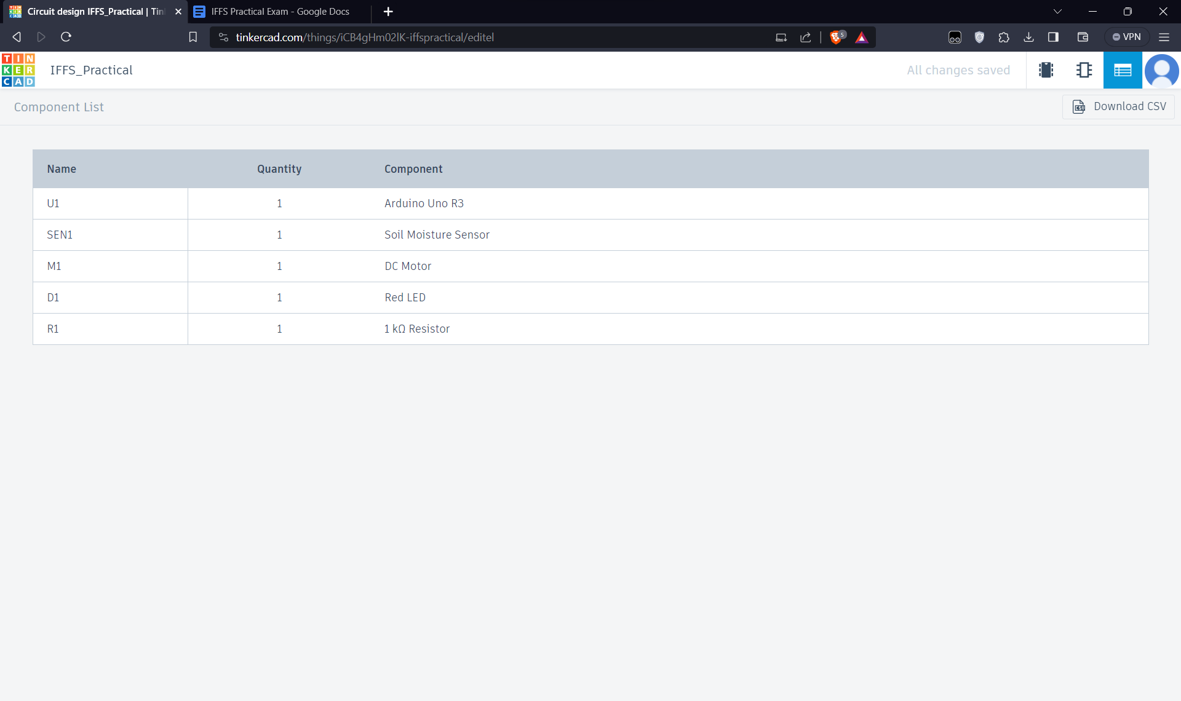

**Program:**

void setup()

{

pinMode(8, OUTPUT);

pinMode(7, OUTPUT);

pinMode(A0, INPUT);

Serial.begin(9600);

Serial.println("Rohit Luni");

Serial.println("========================");

}

void loop()

{

int moisture_value = analogRead(A0);

Serial.println(moisture_value);

if(moisture_value > 500)

{

Serial.println("Motor is ON");

digitalWrite(7, HIGH);

digitalWrite(8, HIGH);

}

else

{

Serial.println("Motor is OFF");

digitalWrite(7, LOW);

digitalWrite(8, LOW);

}

delay(1000);

}

**Output:**

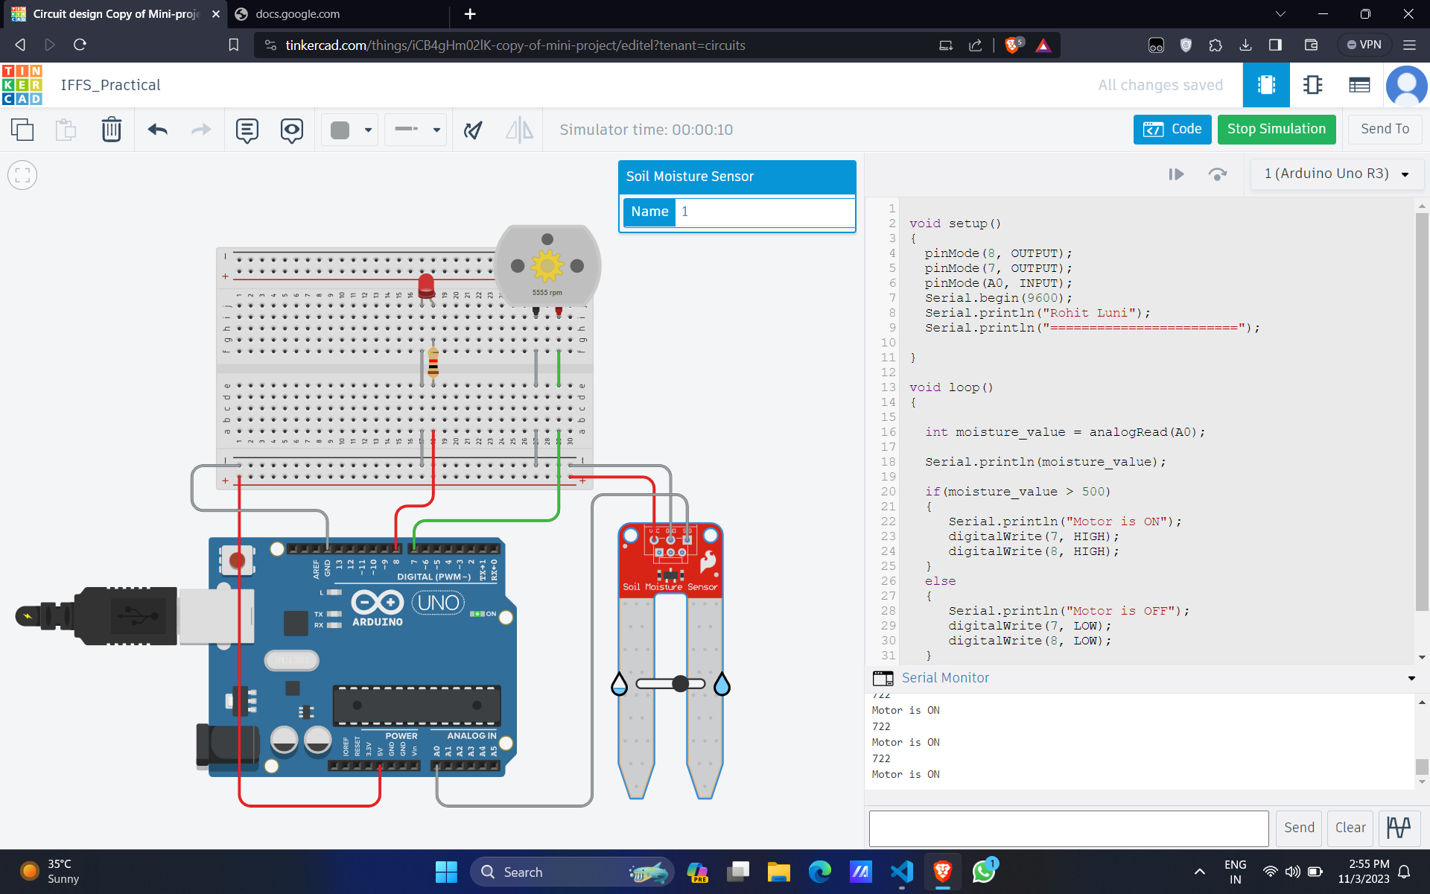

**Conclusion**

Thus, learnt about basic components of IoT like Arduino UNO, Soil Moisture sensors, Motor and LED